Object Oriented Programming
Lab

SPRING 2026

LAB 03



FAST National University of

Computerand Emerging Sciences

Learning Outcomes

In this lab you are expected to learn the following:

• Double Pointers

• Dynamic Memory Allocation
POINTERS

A pointer is a variable that stores an address of a memory location.

Pointer Declaration and initialization

Pointers is declared as follow.

Type* <variable Name>;

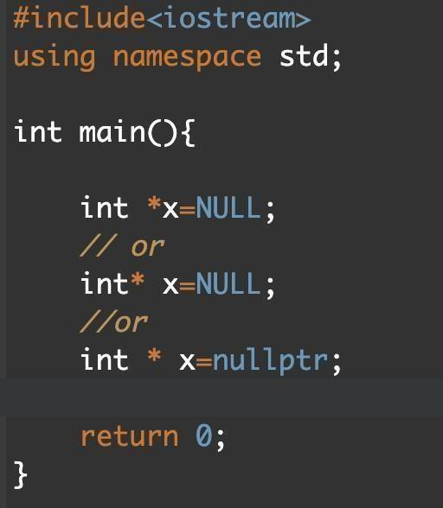

Address-of operator (&)

The ampersand, &, called the address of operator, is a unary operator that returns the address of its operand.

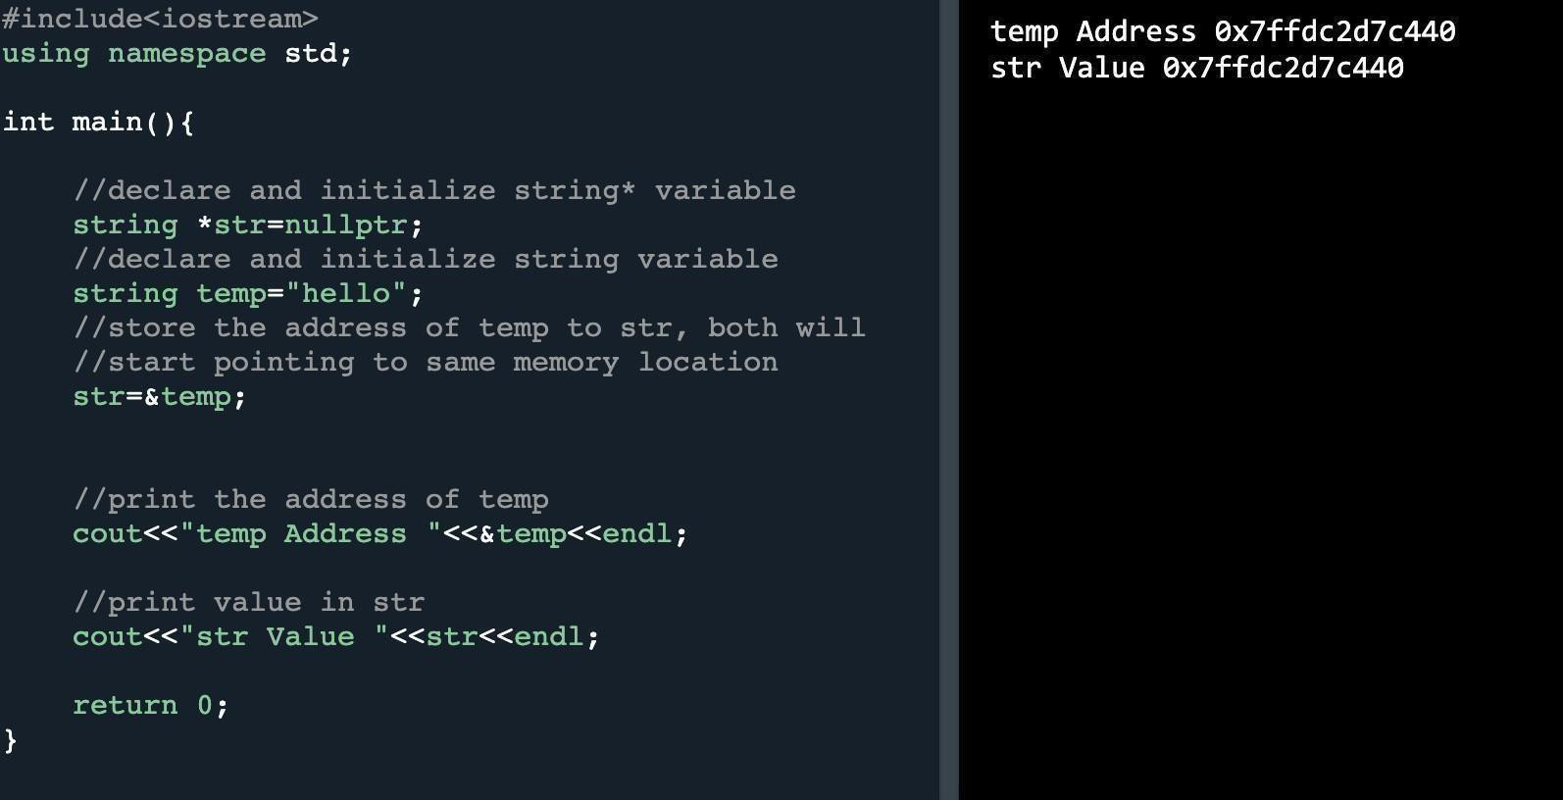

Dereference operator (*)

The unary operator * is the dereferencing operator that returns the value of its operand.

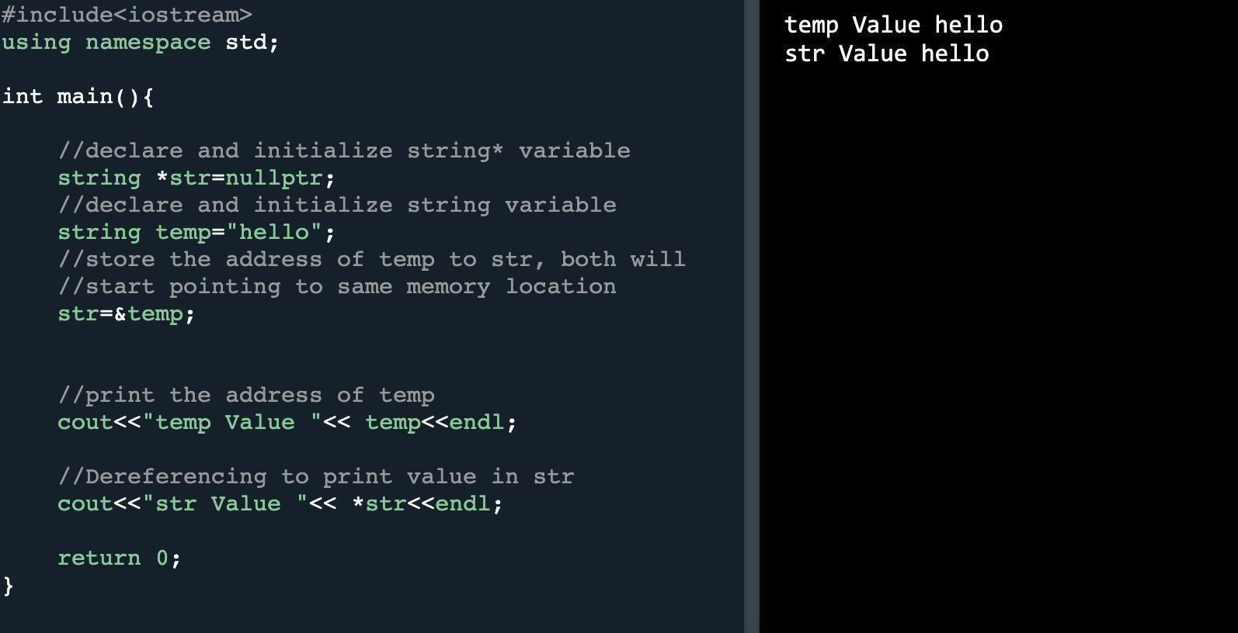
Initializing double pointers

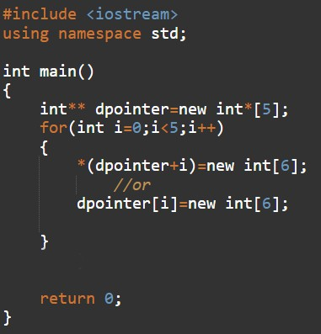

Traversing double pointers

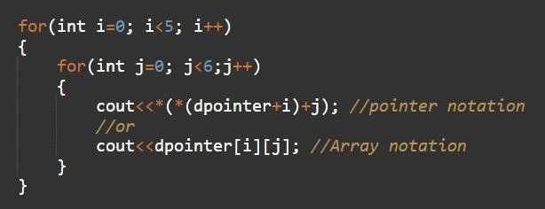

Problem 1:

In this task, create a function that will take a i. 2D pointer
ii. Number of rows
iii. Number of columns as argument

Create a 1D dynamic array Result of size 4 to store the sum. Sum will be calculated on the basis of following conditions

(i) At zero index of Result array, store sum of all values with even row no. and even column no. (ii) At 1st index of Result array, store sum of all values with even row no. and odd column no. (iii) At 2nd index of Result array, store sum of all values with odd row no. and even column no (iv) At 3rd index of Result array, store sum of all values with odd row no. and odd column no

Return the result array.

Function Prototype: int* sumArray (int** arr,int rows,int cols)
Note: Use pointer notation

Problem 2:

Given a matrix, return the sum of the matrix diagonals. Only include the sum of all the elements on the primary diagonal and all the elements on the secondary diagonal that are not part of the primary diagonal.

Function Prototype: int diagonalSum(int** matrix,int size)

Example:

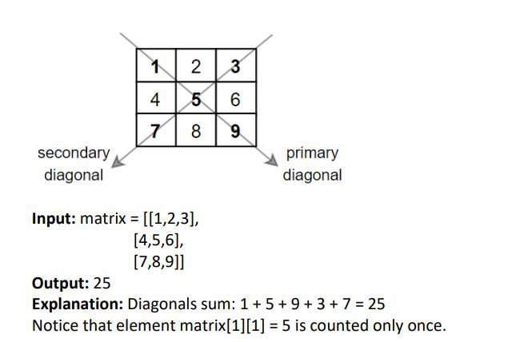

Given a m x n matrix grid which is sorted in non-increasing order both row-wise and columnwise, return the number of negative numbers in a grid.

Function Prototype: int countNegatives(int** grid, int rows, int columns)

Example 1

Input grid = [[4,3,2,-1],[3,2,1,-1],[1,1,-1,-2],[-1,-1,-2,-3]]
Output 8
Explanation There are 8 negatives number in the matrix.

Example 2

Input grid = [[3,2],[1,0]]
Output 0

Problem 4:

Given an m x n integer matrix matrix, if an element is 0, set its entire row and column to 0's. You must do it in place.

Function Prototype: int** setZeroes(int** matrix,int rows, int columns)

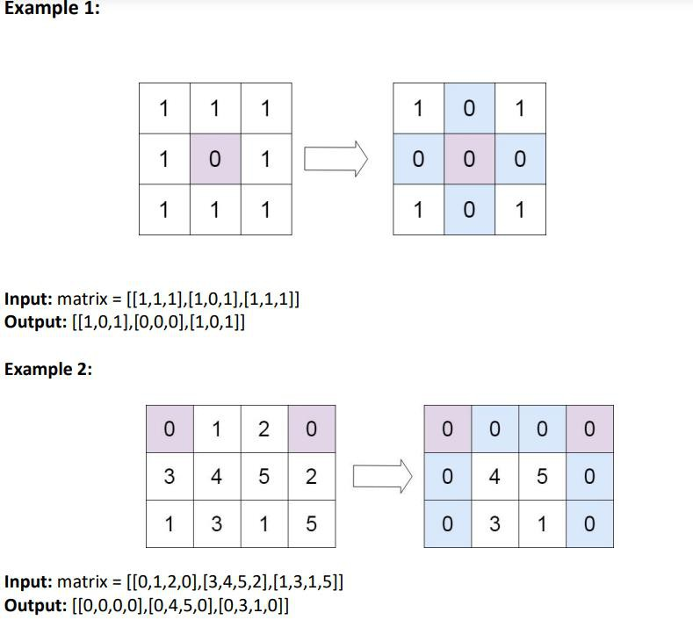

Problem 5:

You are given a 0-indexed 1-dimensional (1D) integer array original, and two integers, m and n. You are tasked with creating a 2-dimensional (2D) array with m rows and n columns using all the elements from the original.

The elements from indices 0 to n - 1 (inclusive) of original should form the first row of the constructed 2D array, the elements from indices n to 2 * n - 1 (inclusive) should form the second row of the constructed 2D array, and so on.

Return an m x n 2D array constructed according to the above procedure, or an empty 2D array if it is impossible.

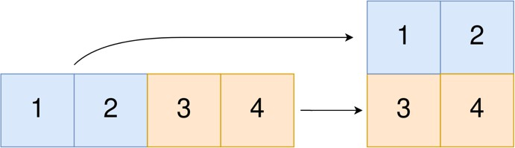Function Prototype: Int** construct2DArray(int* original, int m, int n) Example 1:

Input: original = [1,2,3,4], m = 2, n = 2
Output: [[1,2],[3,4]]
Explanation:
The constructed 2D array should contain 2 rows and 2 columns.
The first group of n=2 elements in original, [1,2], becomes the first row in the constructed 2D array. The second group of n=2 elements in original, [3,4], becomes the second row in the constructed 2D array.

Submission Instructions:

1. Now create a new folder with the name ROLLNO e.g.i254XXX.
2. Move your .h and .cpp files in the folder.
3. Now you have to submit this zipped file on Google Classroom.
4. If you don’t follow the above-mentioned submission instructions, you will be
marked zero.
5. Plagiarism in the Lab Task will result in zero marks in the whole category.

